A special report on pensions: Hiring grandpa
All hands on deck
Apr 7th 2011 | from the print edition

WHEN WINSTON CHURCHILL reached the age of 65, his career was still regarded as a bit of a failure. Had he retired then, as most modern 65-year-olds would, he would never have become prime minister, made the speeches for which he has become famous or topped polls of the greatest Britons ever. Is the rich world ignoring the potential of its older workers whose finest hours could still be ahead of them?
As things stand, the absolute number of people of working age in the developed world is set to fall. In the EU it is likely to drop from 305m in 2010 to 286m in 2030 and just 255m in 2050. Over the same period the number of those aged over 65 in those countries will rise from 87m to 142m.
Economic growth is a function of the size of the workforce, the amount of capital employed and the rise in productivity. If the workforce shrinks, as demography shows it will, all the growth will have to come from capital investment and productivity improvements. In Japan, where the working population is already getting smaller, economic growth has been minuscule, despite a good productivity record. To counteract a shrinking labour force, the retirement age needs to be raised. Around half the countries in the OECD have already acted on this or are planning to do so. In America the age at which full Social Security benefits can be claimed was recently raised to 66 and is due to go up to 67 in 2026.
Working longer has two obvious economic benefits: it boosts output and reduces the length of time for which pensions need to be paid. But governments are barely managing to keep pace with increasing longevity. Between 1960 and 2010 life expectancy at 65 in OECD countries rose by around four years for men and more than five for women.

By 2050 the average official retirement age in the OECD is set to reach around 65, an increase of about 1.6 years for men and 2.5 years for women on today’s figure. But over the same period life expectancy at 65 is expected to grow by around three years for men and three-and-a-half for women. So governments are not gaining any ground.
Changing the official retirement age is only the start. In some countries most people actually retire much earlier. In Luxembourg the official pension age is 65 but men on average leave the workforce at 57.
The actual retirement age in OECD countries fell sharply in the second half of the 20th century. In five European countries it is still below 60 for men and in 11 for women. In America more than half of all workers stop at 62, the age at which they can start drawing Social Security, albeit at a reduced rate. By contrast, the average Japanese man works until he is almost 70. Even then he will still have 15 years of retirement ahead of him. A 70-year-old Japanese woman has a life expectancy of 19 years.
Raising the official retirement age is not much use if people simply draw unemployment or sickness benefit instead of a pension. But fewer jobs now require a big physical effort, and older people’s health has generally improved; in the 20 years to 2004 the proportion of Americans over 65 unable to function independently with ease fell from 26% to 19%.
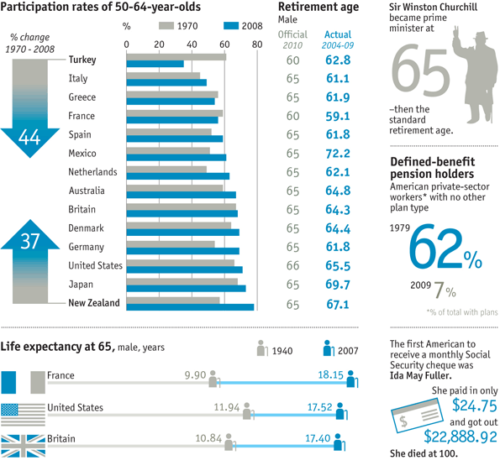
Participation rates for older workers vary widely between countries (see chart). In some countries they have gone down, most notably in Turkey, where for a long time just 25 years of contributions entitled a worker to a full pension. But some countries have also managed to push up their rates. In New Zealand, which increased its official pension age from 60 to 65 over a nine-year period, the employment rate of 60-64-year-olds duly rose from 24% in 1992 to 66% in 2009.
A potential barrier to older people staying on in the workforce is the “lump-of-labour fallacy”—the belief that there is only so much work to go around. In the old days this was used by men to argue against women joining the workforce, and it is still cited by those opposed to immigration today. But it seems obvious that it is better for the economy if a 60-year-old does a productive job than if he is sitting idle, supported by the taxpayer. And the data clearly disprove the fallacy. In Europe the participation rates of those aged 20-25 and 55-59 respectively are positively correlated; in other words, if more older people are working, the chances are that younger people will be too.
As Alicia Munnell and Steven Sass point out in their book, “Working Longer”, the trend for American men to retire early started to reverse after 1990. That may have been for a variety of reasons: the shift from manufacturing work that often involved heavy manual labour to a service-based economy; a more highly educated workforce (brainpower declines more slowly than physical ability); and women’s recent tendency to return to work when their children have left home.
Shifts in pension provision in themselves can make people want to work longer. Most defined-benefit schemes have either a set retirement age or a mandatory number of contribution years before a full pension can be drawn. Once those conditions have been met, there is little financial incentive to keep working. But in a defined-contribution scheme another year of work probably means a better pension. Surveys suggest that people in DC plans retire a year or two later than those in DB schemes.
But even if people in their 60s want to keep working to improve their pensions, will employers want to hire them or keep them on? A study by America’s AARP (formerly the American Association of Retired Persons) in 2002 found that two-thirds of older workers had witnessed or experienced discrimination on age grounds. One problem is perceived productivity. Ms Munnell and Mr Sass cite a study of human-resources professionals indicating that older employees were valued for their loyalty and reliability but less highly rated in terms of flexibility, showing initiative and understanding technology.
The shift to DC pensions might help change employers’ attitudes as well. Older workers have traditionally earned more, reflecting the weight of seniority in pay scales, so the cost of providing final-salary pension benefits for them has been higher. Christine Mahoney of Mercer Consulting reckons that the cost of funding a 60-year-old employee in a DB scheme is 12% of payroll, whereas in a DC plan it is just 6%. In America, where employers are expected to provide health care, older workers are also more expensive to insure. On the other hand such workers may be more flexible on pay, particularly if employers are willing to offer part-time work, which many older people prefer. That might make them more attractive to hire.
In the long run, employers will probably change their recruitment practices. Because of demographic factors, workers in their 20s and 30s will simply not be around in the same numbers as before, so the market for them will become much more competitive. Some jobs may be outsourced to developing countries but there will be plenty, particularly in the services sector, that cannot be. Unless a greater number of older workers stays in the labour force, wages are likely to be bid up sharply.
B&Q, a British DIY retailer, has been recruiting older workers since the 1980s, after a pilot project showed that having more of them around improved customer services and sales and reduced staff turnover and absenteeism. Perhaps some day employers will be giving 65-year-olds a gold watch when they join the company.

Define these words in one English sentence:
Lump-of-labour fallacy

Positively correlated

Defined benefit (pension) scheme

Defined contribution (pension) scheme

Final-salary pension benefits

Staff turnover

Absenteeism

Answer these questions:
1. Why will a declining working population cause economic stagnation?

2. Why did the trend for American men to retire early start to reverse after 1990?

3. Why does having a defined contribution scheme cause people to delay retirement?

4. What are older employees perceived as being good for and perceived as being bad at?

5. Why does the article think that wages for young people will rise sharply in the future if they are working in the services sector?

