28 Europe
The Economist January 29th 2011

Charlemagne | The trouble with Flanders
Why Belgium's unending linguistic disputes matter to Europe

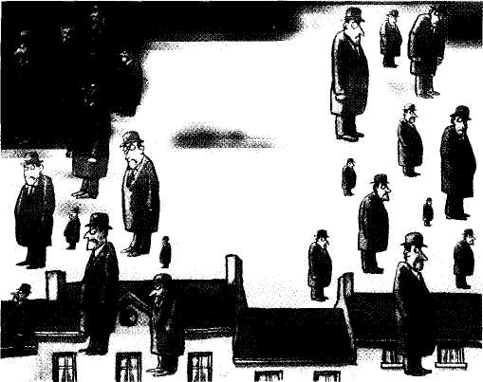
m
PITY the books of Leuven, a seat of learning since 1425. The Dutch humanist Erasmus taught at the university; Mercator, the Flemish cartographer who projected the globe, learnt maths there. But besides intellectual ferment, Leuven has known much cultural vandalism. Some manuscripts were carted to Paris when French revolutionaries closed the university. The library was set ablaze by the Germans in the first world war. It was rebuilt with international (mainly American) help, and burnt again in the second world war.
In 1968, though, it was the Belgians themselves who cleft the book collection during their language wars. To Flemish students' cries of Walen Buiten ("Walloons Out"), the French-speaking bit of the university was ejected. The library's 1.6m books were divided, often by the crude expedient of keeping odd-numbered tomes in Leuven and sending even-numbered ones to the new campus of Louvain-la-Neuve, in French-speaking Wallonia.
The 1968 partition divided the Catholic church (both universities are Catholic) and brought down the government. Belgium's conservative Catholic party split into Francophone and Flemish halves, followed by the liberals and the socialists. Belgian politics became tribal, with each party championing its own linguistic agenda. Over the years these rows have turned Belgium into a near-ungovernable federation, with powers devolved downwards. The Belgian state has become a hollowed-out shell, with a little-loved flag and a forlorn sovereign, Albert II, who could yet end up as the last king of the Belgians-indeed, the last Belgian.
Chronic bickering since the election in June 2010 has left a caretaker government in office for 230 days and counting, a European record. Belgium is on course to beat Iraq's 289 days without a government. Yet the country has so many layers of administration that daily life goes on. Belgian ministers made a decent fist of their country's six-month rotating presidency of the European Union in the second half of 2010. Eurocrats in Brussels are only faintly aware of living in a paralysed country. And, despite a few recent wobbles, the bond markets seem largely unconcerned about Belgium's giant public debt of close to 100% of gdp. It was only on January 23rd that Belgian students organised protest rallies to urge their country's politicians to get a move on.
The world gives little thought to Belgium. Yet it may soon have
to pay more attention. As the crisis drags on, a break-up of Belgium looks less unthinkable than it was. The effects would be felt far beyond the fantasy world of Tintin and Magritte's bowler-hatted men falling from the sky.
Paradoxically the slow dissolution of Belgium, the most pro-European of countries, goes hand in hand with the (uneven) deeper integration of the eu. Belgium is facing its worst troubles just as the eu confronts the gravest challenge to the euro. One way of looking at Belgium's divide is as a counterpart to the eu's split between a Germanic, frugal north and a subsidy-dependent Latin south. Financial markets stand ready to dump Belgian bonds at any hint of formal partition, because of uncertainty over who would repay the country's debts. But, for the moment, the euro gives all parties the luxury of intransigence. Without it, the stalemate might have triggered a run on the Belgian franc.
Today's blockage is unlike previous ones in that an avowedly separatist party, the New Flemish Alliance (n-va), has for the first time become dominant in Flanders. Led by Bart de Wever, a charismatic bruiser, the n-va's appeal stems precisely from popular exasperation with the messy, unsatisfying compromises of the older political groups. It wants a decisive shift of powers to Flanders, and makes little secret of its wish to see Belgium "evaporate" within the eu. Danny Pieters, the n-va president of the Belgian Senate, says he sees no need for a Flemish army: one day Belgian forces will be part of a European one. For the n-va, Europe is the acid that will help to dissolve Belgium.
Strangely, perhaps, this same erosion of sovereignty is seen as an antidote to violent nationalism. European integration overcame the historic enmity between France and Germany. Ireland's entry into the eu helped to end the worst of Northern Ireland's sectarian war. In the Balkans, the eu offers the balm of membership to heal the trauma of the Yugoslav wars. But is this not all romantic nonsense when Belgium, a founder of the eu as well as the host to its capital, struggles to hold together? No, says Mark Leonard, director of the European Council on Foreign Relations, a think-tank. By "taking the gun out of politics", the eu has contradictory effects. It makes it easier to draw violent groups into politics; but it also allows peaceful nationalists to act up, and voters to support them, because there is no danger of bloodshed.
Put the carving knife away
This does not mean that Belgium can dissect itself without anybody worrying. Spain and Italy would not be the only places to fret about the precedent of rich regions pulling away from poorer ones. Scottish nationalists speak of independence within Europe. Many ex-communist countries have big national minorities: think of Hungarians in Slovakia. Redraw Belgium and break the mystique of European tolerance-and one creates doubts across much of the eu's eastern swathe.
Changing national borders only rarely resolves nationalist and ethnic disputes. Where communities overlap, tolerance, minority rights, autonomy and cross-border co-operation are better democratic tools. Take Brussels. If Flanders breaks away from Belgium, could Brussels, officially bilingual but overwhelmingly Francophone, leave Flanders? Indeed, this conundrum offers the best hope that, in the end, Flemings and Walloons will live together somehow. Splitting a city is harder than breaking up a uni-versity-luckily for Belgium, and perhaps for Europe. ■
Economist.com/blogs/charlemagne

