The Economist March 19th 2011
Business 59

Greek business nightmares
Cursed are the cheesemakers
ing piecemeal instead of making a bonfire of such outmoded restrictions. There is still a chorus of complaint from Greek entrepreneurs about the government's timidity in pushing its reforms.
"Sometimes you feel stupid doing business here," says Stefanos Panteliadis, the chief executive of Epirus, a maker of feta cheese in the eponymous north-western region of Epirus. Every year Mr Panteliadis is vexed by the legal requirement for companies to publish their balance-sheets in two national newspapers and a regional one. Although publishers welcome the revenues this outdated rule brings, it is a
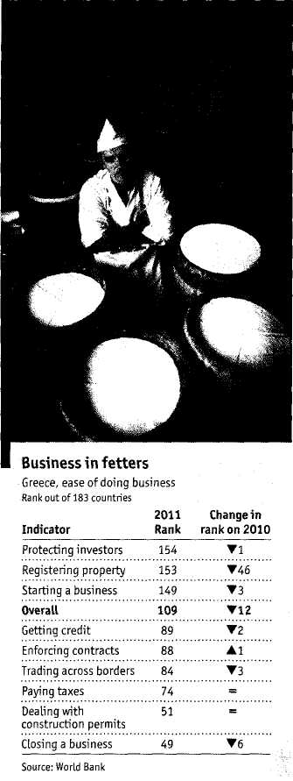
Greece's government is promising to make life less dismal for businesspeople. It has a long way to go
GREECE has been a leftist country
since 1974," laments Yannis Stour-naras, head of iobe, a private-sector think-tank. Perched behind his desk in an office not far from the Acropolis, Mr Stournaras argues that the pendulum of Greek politics swung to the left after the end of the military dictatorship and has stayed there ever since. The result is a state-heavy economy with excessive and contradictory legislation that is strangling the private sector.
Greece's rankings in the World Bank's latest annual "Doing Business" survey, published in November, were strikingly poor for a rich, supposedly modern country that has been a European Union member for 30 years. As other governments around the world pushed ahead with liberalising reforms, Greece slipped 12 places in the bank's league table of 183 participating countries (see chart), ending up behind Paraguay and Bangladesh. Opening a new business in Greece is well nigh impossible; closing one is somewhat easier.
Greek companies are constrained by a raft of what locals call "counter-incen-tives"-laws and bureaucratic hurdles that make it hard to do business, iobe has counted 250 of them. Some of these are now being abolished thanks to the tough austerity and reform package that was the condition for a €110 billion ($145 billion) Joan from the eu and the International Monetary Fund, which prevented Greece from defaulting last year. On March 12th the eu gave Greece more time to repay the union's €80 billion contribution to that bail-out package, and cut the interest rate, in return for the Greek government promising to raise €50 billion from privatisations in the next five years.
The Socialist government is making some progress in opening a closed economy against resistance from a myriad of vested interests. It forced open road haulage, one of the most notorious of nearly 70 closed-shop trades and professions, by doubling the number of lorry licences. Pharmacists had to swallow the end of their 35% profit margin on prescription drugs. The privileges of lawyers, civil engineers and architects will be next.
iobe estimates that freeing up all the closed professions could boost Greece's Gdp by up to 17%. But given the huge potential gains and the country's urgent need for a growth boost, Spiros Giamas, the boss of CDMedia, a distributor of video games, wonders why the government is reform-
pointless expense for companies which, like Epirus, make all their figures available on the internet. The only regional paper in Epirus charges local companies even higher advertising rates than national dailies, because they have no alternative.
This is one example of many business-unfriendly laws that are obsolete or so complex that they leave plenty of scope for bureaucrats to interpret them arbitrarily. Greece's previous government, run by the conservative New Democracy party, passed a law on promotional pricing in supermarkets that required goods to be labelled with as many as nine prices, including the cost before and after the promotion, with and without tax, per kilogram, and so on. When the Socialists got in, they made this law more complicated still, sighs Mr Panteliadis.
More taxing than ever
Orsalia Partheni, who runs a fashion retailer and manufacturer in Athens, says that corporate taxes and social-security contributions are the biggest burden on her business. Last year, she was faced with "urgent" taxes, ad hoc levies to alleviate the country's financial crisis, which made a difficult year even trickier. She recently had to close a shop in Nea Erythraia, a fashionable part of Athens. One in every two shops in Kolo-naki and Glyfada (two trendy Athens neighbourhoods) has closed, says Ms Partheni. They cannot pay the high rent for the location as well as the additional one-off payments of more than €100,000 that landlords are insisting on passing on to tenants.
Vanya Veras gave up even trying to set up a company because she found the process too expensive, too complicated and too long. She freelances as an environmental consultant in partnership with Oikos-teges, a company that makes rooftop gardens. There is no shortage of pointless laws in her line of business. While writing a waste-management plan for a municipality she discovered that for some reason composting is only allowed in industrial zones, which put an end to the municipality's plans to recycle its plant matter.
By nature and inclination Greeks are entrepreneurial. Greek immigrants in America and Australia tend to do well with restaurants, corner shops and other small businesses. Yet only the very resilient and those prepared to cut corners survive the anti-business environment back home, iobe's Mr Stournaras believes that the current crisis will be cathartic and that after five tough years Greece will recover. It remains to be seen how many entrepreneurs can hang on until then. ■

