The Economist, Special Report, March 3rd 2011

When the roof fell in
Housing will be a drag on the rich world’s recovery for the foreseeable future
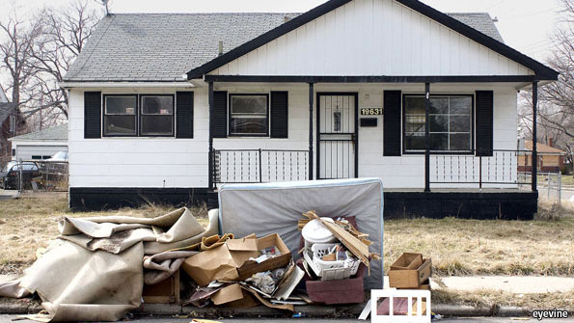Walls of worry
PROPERTY can cause huge problems, but the sector also traditionally leads economies out of recession. Housing is far bigger and more important than commercial property. Residential investment, which is driven by new housing starts, makes up a large chunk of the volatile bit of the economy. That means changes in residential investment have a disproportionate impact on rates of GDP growth. It has played a big part in driving previous post-war American recoveries, and many assumed the same would happen this time round. Things have not worked out that way (see chart 3).
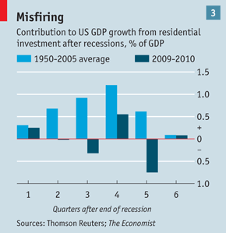
Around much of the rich world, hopes that housing markets would be well on the road to recovery by now have been disappointed. Not everyone is glum. Renters are not bothered by falling prices, and the cash-rich are still having a high old time. But for most people property is a source of worry.
In America the bounce caused by a temporary tax credit for first-time buyers has long since faded. The latest S&P/Case-Shiller home-price indices (which take in figures up to December 2010) showed that prices had fallen in 19 out of 20 cities covered month-on-month, and that the composite index had declined by 2.4% year-on-year. Eleven markets, including Miami, New York and Seattle, hit their lowest levels since prices first started falling in 2006.
Misery index
In Britain a strong start to 2010 also weakened as the year went on. Figures from Nationwide, a lender, showed a 1.1% year-on-year fall in prices in January, the biggest slide since August 2009. In Spain the IMIE index showed a fall of 3.9% in December, taking prices back down to levels last seen in 2005. For sheer awfulness nothing can touch Ireland, where prices dropped by 10.8% in the fourth quarter and the rate of decline increased.
It comes as no great surprise that many markets are still struggling. A common thread in many rich-world economies is uncertainty about the future. Policymakers may worry about the effect of housing problems on unemployment—homeowners in negative equity may not be able to move in search of jobs—but the more important effect runs the other way. Changes in hiring rates are an excellent predictor of homeowners falling behind with their mortgage payments. Fears about sovereign-debt crises, the effects of austerity programmes and job security make it far less likely that people will take the plunge on buying a new home.
Another common feature is a squeeze on mortgage finance. The private market for securitised mortgage loans remains very subdued. Banks have belatedly tightened credit standards, particularly for first-time buyers, who lubricate the housing market for everyone else. According to recent research in Britain by the Home Builders Federation, a trade group, the average first-time buyer aged 30-39 would now have to save 35% of his or her pay after tax every month for five years to scrape together a deposit. Many are turning to the bank of Mum and Dad for help.
In America the government has rushed in to take up the slack. Fannie Mae and Freddie Mac, which buy home loans from lenders, and the Federal Housing Agency (FHA), which insures them against default, between them routinely guarantee more than 85% of new home loans. FHA-insured loans are particularly important for first-time buyers, who need to put down a deposit of only 3.5%. The market is so dependent on these agencies that the government will not be able to withdraw its support any time soon (which is one reason to expect the winding down of Fannie and Freddie to be slow in coming).
Even so, there is a limit to governments’ willingness to take on more risk. Fannie and Freddie have been fighting with the banks about poor-quality loans they originated and then passed on to the agencies. The FHA has gradually been tightening its insurance criteria. Add in the fallout from the “robo-signing” scandal, in which banks were accused of using flawed and possibly fraudulent foreclosure processes, and mortgage approvals will stay sluggish.
Much as these demand-side factors dampen the housing market, the supply side arguably has an even bigger effect on prices. Work on the relationship between housing supply and bubbles by Edward Glaeser of Harvard University and Joseph Gyourko and Alberto Saiz of the Wharton School suggests that places with relatively elastic supply have fewer bubbles, of shorter duration, than those where the supply is more restricted.
Dearth and homes
In many respects the recent boom bears this out. Differences in supply constraints can explain much of the striking disparity between American states, from the modest run-up in prices in Texas, where land is easily available, to the huge surge in places like Nevada, where land-use regulations are tighter.
But elasticity is not always a good thing. When the housing market can respond to demand by adding to supply, there is a greater risk of overbuilding. In theory, booms in elastic markets do not last for long because as new housing becomes available it puts pressure on prices, puncturing expectations of further appreciation and popping the bubble. For the 1996-2006 cycle in America Messrs Glaeser, Gyourko and Saiz find that places with more developable land did have shorter booms.
But when it comes to the biggest house-price bubble in history, theory does not get you very far. In some places the boom was big enough and irrational enough to suppress price signals from lots of new supply. Instead, availability of land simply fed speculative activity, which has made the popping of the bubble much more painful.
In a report last December the Bank of Spain reckoned that the country has a glut of 700,000-1.1m unsold homes, which will continue to weigh on prices this year. Bernstein Research estimates that these unsold houses will take four to five years to clear, and even that may be too optimistic given high unemployment, the threat of a sovereign-debt crisis and fewer immigrants. It could have been worse: Spanish banks have repossessed huge amounts of land that had not yet been built on, and residential-mortgage standards are rather conservative. But the oversupply means that prices will keep falling. They have dropped by only 16% from their peak in real terms, and Bernstein reckons the eventual fall will be more like 30%.
Ireland’s building boom also went over the top. The government relaxed planning laws, the banks threw money at anything involving cement, and investors gobbled up houses in the expectation that prices could only go up. An Irish government report last October into the country’s “ghost estates” identified more than 2,800 housing developments where construction had been started but not completed. Between them these estates had planning permission for 180,000 units, which roughly translates into a new residence for one in every 25 Irish people.
A lot of properties were sold before the market soured, so the report found only 33,000 finished homes remained empty, not the hundreds of thousands forecast earlier. But even if the overall number of unsold units is not as bad as feared, it does not capture the full effects of oversupply.
Take Clongriffin, a huge mixed-use development north of Dublin. The location is good, about 15 minutes from the city centre. Flags extolling “Dublin’s new town centre” hang from lamp-posts outside the local railway station, which opened in 2010. There are some shops on the main street, and cars in many of the driveways. But the overall impression is bleak. Many shops are unoccupied, lots of apartments lie unfinished and there is no sign that work is continuing. Hoarding surrounds large tracts of undeveloped land.
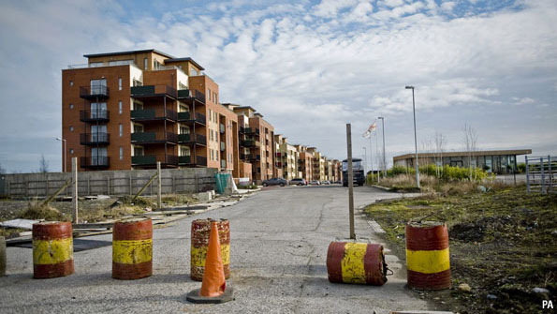Ghosts of Ireland’s boom
Mixing vacant and unfinished properties with occupied ones drags down the value of everything. The bust also gives developers very little incentive to resolve disputes over maintenance. Clongriffin is one of a number of north Dublin developments involved in legal cases over buildings contaminated with pyrite, a mineral that crumbles as it oxidises.
Clongriffin may also have the wrong sort of properties for this stage of the cycle. During the boom much of the construction activity was in flats. Developers liked them because they could generate more revenue from a single plot of land. First-time buyers saw them as a way to get onto the housing ladder, perhaps hoping to trade up to a house later. But prices have now fallen so far that buyers can skip the flat and go straight to a family home.
Clongriffin’s unsold units will probably find buyers in the end, thanks to its location. Two-fifths of Ireland’s population lives in greater Dublin and the country has one of the highest proportions of 25-45-year-olds in Europe, most of whom will want to own their homes. But lots of the excess was in more rural areas. Marie Hunt of CB Richard Ellis (CBRE), a property consultancy, points out that in such places even an oversupply of 20 homes can make a big difference.
Only in America
Oversupply can take many forms. America’s big housing worry is its huge “shadow” inventory—homes whose owners are seriously behind with their mortgage payments or in foreclosure and which will eventually come onto the market. Even though American house prices are now back at fair value (ie, the ratio of house prices to rents is back to its long-run average), this pipeline of distressed properties is putting prices under continued pressure.
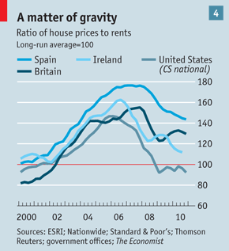
It also helps explain why America has suffered such a sharp fall in prices after the bust despite peaking lower than many other countries (see chart 4). House prices are generally “sticky” on the way down, in part because people are averse to selling at a loss. But America’s bust has brought waves of distressed sales, forcing prices down rapidly. Around a quarter of borrowers are now in negative equity. “The big question is not how fast prices rose but how fast and how much they fell,” says Eric Belsky of the Joint Centre for Housing Studies at Harvard University.
One explanation is that unemployment in America rose more sharply than in other rich economies, and even creditworthy borrowers cannot cope with a sustained loss of income. But the initial drop was down to causes more specific to housing. The most obvious culprit was the extraordinary laxity of America’s mortgage-underwriting standards in the later stages of the boom. With very little equity in their homes to protect them from a drop in prices, lots of high-risk borrowers quickly became submerged when the bubble burst. Housing boffins regard negative equity as the best predictor of default, which is why they take loan-to-value ratios very seriously. It is also what saddles banks with losses when homes end up in foreclosure.
A related issue is the amount of “strategic defaulting” in America: the number of people choosing to walk away from their homes. Its prevalence can be exaggerated, but it has still come as a surprise. Before the crisis the conventional wisdom had been that people would do whatever they could to stay in their houses, giving priority to mortgage payments over all other forms of debt. But Andrew Jennings of FICO, the company behind America’s FICO credit scores, reckons that 25-30% of defaults are now premeditated. He says that many borrowers, often nominally lower-risk ones, prepare for default by making more credit inquiries and taking up other loans. The practice is more widespread in the many American states where lending is “non-recourse”, meaning that lenders cannot come after a defaulting borrower for any debt left over when the property is sold.
In Europe’s frothier markets unpaid debt hangs around the necks of borrowers, giving them a bigger incentive to tough it out in their homes. Speculative purchases also made things worse: people are more likely to give back the keys to homes they are not living in. The report of the Financial Crisis Inquiry Commission pointed out that by the first half of 2005, the peak year for housing sales, more than one in every ten house sales in America was for an investment or a second home.
Housing, flat
Whatever the reasons, the number of properties that have gone into negative equity and into foreclosure is much greater than expected. A system set up to deal with 500,000 foreclosures a year is now running at about 2m a year, says Michelle Meyer of Bank of America Merrill Lynch. Just how bad this glut of unsold houses will get is very hard to say. It depends, above all, on the unemployment rate. But it also depends on the speed and outcome of the foreclosure process and on the efficacy of official interventions. The experience to date has been uninspiring. A government programme to modify mortgages, giving struggling homeowners a subsidy on their payments, has had $50 billion allocated to it, but so far only $1 billion of that has been spent. Many of those who have had their mortgages modified wind up defaulting again.
Sean Dobson, the chairman of Amherst Securities, is more bearish than most. He argues that some 11.5m American homes (out of 125m in all) remain at risk of ending up in foreclosure, and that principal forgiveness for borrowers under water is the only option: “You are not going to create new buyers for 11m homes, short of legalising every illegal immigrant and forcing them to buy a house.”
Others are less apocalyptic, particularly as America’s recovery gathers pace. But the pipeline of distressed homes heading for the market will keep prices down for some time yet. Sandipan Deb of Barclays Capital reckons that the number of such properties probably totals around 4m-5m. He says that prices will fall by 6% or so in 2011 and will then languish for a while before gradually recovering. That may be just what policymakers want. “The objective of the government is to make sure that distressed stock does not hit the market suddenly,” says Mr Deb. Modifying home loans may not avoid defaults altogether, but it should at least space them out.
Despite the woes, America’s system of long-term, fixed-rate mortgages at least ensures that borrowers do not have to worry about interest rates. Many European countries have adjustable-rate mortgages that move in step with changes in official interest rates: two-thirds of the outstanding mortgages in Britain, for example, are of this kind. Much as European borrowers have been helped by ultra-low interest rates so far, they will also be exposed to rising costs when rates go up again. With house prices in Europe having fallen less far, austerity threatening higher unemployment and inflationary pressures prompting hawkish talk about tighter monetary policy, the continent’s housing markets look more likely to suffer new shocks than America’s.

