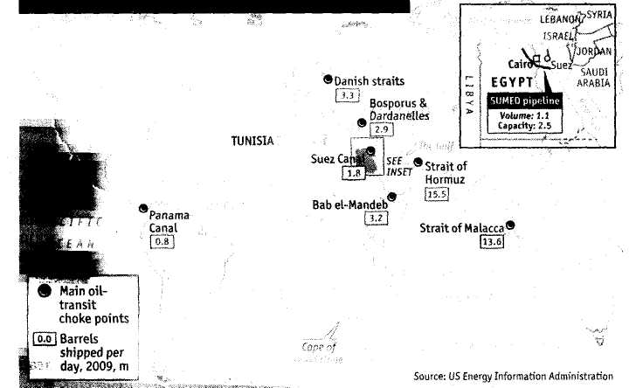
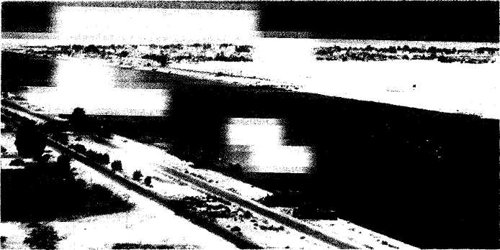
Finance and economics
67
Commodities and the Middle East
Protests and the pump
The Egypt effect may be more pronounced for food than oil
T
ger route: Gulf oil bound for Europe could be dispatched east and African oil bound for Asia sent to Europe instead.
The world is in any case in a position to take some pain. It has decent stores of oil. As Adam Sieminski of Deutsche Bank points out, oecd inventories, with enough to cover 59 days of consumption, are relatively high compared with the historic average of 55 days. But the amount that China, the world's second-largest importer, has in reserve is unclear.
A far bigger concern in oil markets is that the troubles in Tunisia and Egypt could spread more widely in the Middle East, given the same mixture of unemployment, inequality and autocratic government that has underpinned the unrest in
HE tide of unrest sweeping Egypt has whipped up waves in the oil market. Anxiety often has a role in determining the price of black gold and traders, with plenty to fret about, sent a barrel of oil above $100 for the first time in two years on January 31st. Fears abounded that the upheavals in Egypt might disrupt the passage of tankers through the Suez Canal and, worse still, that the popular uprisings in Egypt and Tunisia might spread across the Middle East.
So far the concerns seem overblown. Egypt is a small producer and actually imports a little oil. It is better known for its role as a transit route. Over 4% of global supplies of oil—after the lows of 2009 that equates to nearly 4m barrels a day now, according to Barclays Capital-are transported through the country, either by ship on the Suez Canal or along the sumed pipeline (see map). Crude and refined products travel both ways on the canal (along with many other goods). But there is little hint that Egyptian authorities have any intention of disrupting this trade or that protesters have the means to prevent the oil from moving, even if they wanted to.
Route canal
If the canal shuts down, the pipeline has the spare capacity to take much of the displaced crude northward. Even a total halt would be far from catastrophic. There are plenty of spare tankers that could shift Gulf oil the long way to Europe around the Cape of Good Hope-putting a couple of weeks and some added expense on the journey. Some rebalancing of global flows might lessen the impact of plying the lon-

The Economist February 5th 2011
Also in this section 68 Inflation: where to worry
- America's housing morass
- Upheaval at Spain's cajas
- Crime in carbon markets
70 Citigroup takes over EMI
72 Economics focus: Germany's decade
For daily analysis and debate on economics, visit Economist.com/economics
Egypt and Tunisia (see page 21). But even if similar problems did arise in the Gulf, Algeria or Libya it is far from clear that the spigots would be turned off. The most recent war in Iraq disrupted Gulf oil supplies for only three weeks.
Events in Egypt may turn out to have a greater impact on other commodities, notably food. High food-price inflation has cut spending power across emerging economies (see next story), where keeping bellies full accounts for a much larger share of income than in rich countries. The high cost of food is one reason that protesters took to the streets in Tunisia and Egypt. The price of bread has shot up since last summer when a drought in Russia, one of the world's largest wheat suppliers, hit harvests and prompted an export ban.
Analysts at Goldman Sachs point out that countries in the region may feel the need to head off political instability by spending to stockpile grain. Saudi Arabia, Algeria and Jordan have all stepped up efforts to build stockpiles. This could raise the pressure on other countries to hoard wheat, pushing prices even higher. In the short term this might even result in lower ►►

The Economist February 5th 2011

► oil prices if opec countries pump more out of the ground to raise cash to assuage uppity populations.
Irrespective of events in the Middle East, however, the pressure on oil prices is likely to grow. The market has recovered very strongly from the lows of 2009 thanks to bumper growth in emerging markets and a decent recovery in America. As Francisco Blanch of Bank of America Merrill Lynch points out, opec has not yet responded with extra supply to tame prices. It regards oil, priced in dollars, as a currency that the Federal Reserve is debasing with its "quantitative easing" money-printing, and would rather leave it in the ground for now. Even if opec eventually makes use of its spare capacity the world's thirst for oil could start to outpace supplies in the next two years. Then $100 a barrel could look like a bargain. ■
Inflation around the world
Parsing prices
Rising inflation is not as worrisome as it appears, at least for now
I
NFLATION is back. Despite a weak recovery in much of the world, the threat of rising prices preoccupies policymakers and the public. Concerns are greatest in emerging markets. Inflation stands at 4.6% in China and 5.9% in Brazil; in India it is almost 10%, if below last year's high. But it is on the rich world's agenda, too (see chart).
Euro-area inflation hit 2.4% in January, according to data out this week. Jean-Claude Trichet, the president of the European Central Bank, has been talking tough, recalling the ecb's July 2008 rate rise when concern over inflation trumped a wobbling economy. In Britain inflation has been above its 2% target since December 2009 and stood at 3.7% in December. Mer-vyn King, the governor of the Bank of England, gave warning in January that it will soon climb to 4-5%. Even in America, where inflation has been at historic lows, it jumped to 15% at the end of last year.
Much of the surge in inflation reflects dearer commodities. As well as oil and food, metals prices have been soaring: the price of copper hit a series of record highs this week. More expensive raw materials will work their way through the supply chain over the coming months, pushing up on inflation. Another part of the story in Europe is the effort to plug fiscal gaps by increasing vat, a consumption tax. A hike in vat at the start of the year will have driven prices higher in Britain in January.
A rise in commodity prices or taxes has only a temporary effect on inflation, how-
ever, with the price rise dropping out of annual comparisons after a year. The stuff of nightmares for central bankers is that this leads to a more pernicious type of inflation. Price rises change expectations of inflation, leading workers to bid for wage increases that preserve their buying power and firms to push through price increases, generating a vicious spiral.
These "second-round effects" are worth losing sleep over, but only when there is already inflationary pressure in the wider economy, from a tight labour market and firms running factories at full pelt. Such overheating seems some way off for advanced economies. The unemployment rate is in double digits in the euro area, above 9% in America and 7.9% in Britain. Wage growth has been weak, running be-lowi% in the euro zone and at around 2% in America and Britain.
Inflation expectations have edged up a little in recent months. But even if workers expected inflation to let rip, they would be in a bind. Karen Ward of hsbc reckons anxious employees won't ask for more pay for fear that they will end up getting the sack instead.
Rich-world economies are also running well below capacity. According to the oecd, in 2010 the G7 economies were anywhere between 2.4% (Japan) and 4.7% (Italy) below potential output. Such estimates are notoriously imprecise. But if the recovery had already eliminated excess capacity they would be in the wrong city, not just the wrong ballpark.
The story is very different in emerging economies. Many of these got back to their pre-crisis levels of output in 2009. With capacity constraints starting to bite, underlying inflation is on the up. Households' inflation expectations are also rising. In China they are at their highest for over a decade and there are signs of growing wage pressure. Higher wages are not, by themselves, a bad thing, especially in a country like China where pay has for years failed to keep pace with rapid productivity growth. The danger comes when loose monetary conditions and an overheating economy mean prices and wages chase
Up, up, not really away
2006 07 08 09 10
Source: JPMorgan Chase *Exduding energy and food
Core* consumer prices, % increase on a year earlier
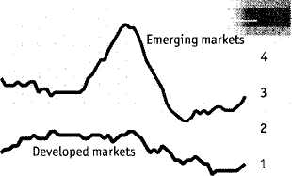
each other upward.
To prevent that, central bankers have been fighting back with higher interest rates and higher reserve requirements. The Brazilian and Indian central banks raised rates last month; in total, they have now hiked their policy rates by 2.5 and 1.75 percentage points respectively. China's central bank recently raised reserve requirements for the seventh time in a year.
For all that, monetary conditions remain extraordinarily loose. According to JPMorgan Chase, real policy rates in emerging economies-the official interest rate minus core consumer-price inflation-are at their lowest level since 2000. Core consumer-price inflation (which excludes food and energy prices) remains below its 2008 levels. But vigilance is needed. A continuation of booming growth and cheap money will cause trouble in the end. ■

