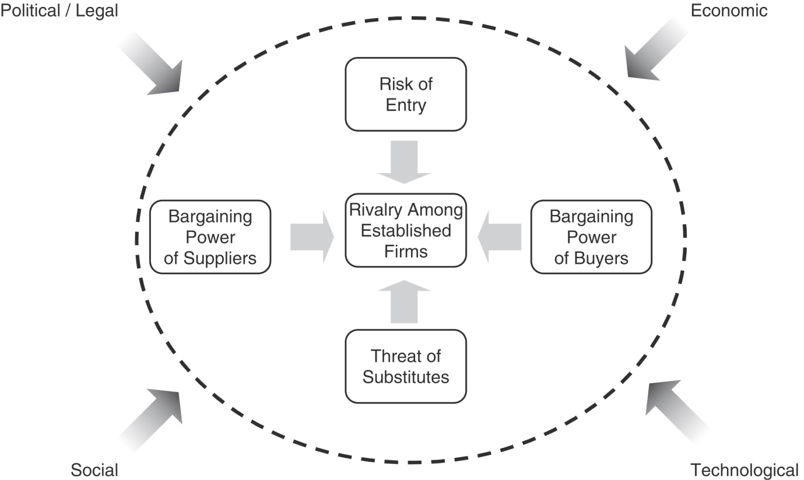

Inside the circle is for assessing the competitive rivalry (Porter’s Five Forces) surrounding your business. Outside the circle are those forces which affect your macro-environment. All these combine to affect your business situation. Here is how to assess your business situation:

Internal Competitive Rivalry
- Define your field of business. If you make cheap mobile phones, then your competitors will be other manufacturers of cheap mobile phones. Maybe it might include manufacturers of mid-range phones. It probably won’t include manufacturers of smartphones.

- Is there a high, medium or low chance of a new competitor entering your market?
- Can your customers dictate how much they will pay you for your product? High, medium, low.
- Is there another product which can substitute for your product? Always remember to include “not using any product of this kind” as an option. High, medium, low.
- Can the suppliers of the components you use to make your product dictate prices to you? High, medium, low.
If all four assessments are high, then typically your market is very intense. Your competitors may overtake you at any moment. If all four assessments are low, then typically your market is easy money. You can sit back, relax and let the profits roll in!

Macro-Environment (PEST)
- Political/Legal: How often does the government change the rules of business regarding your business and its market?
- Economic: Are consumers feeling thrifty or exuberant (économe ou exuberant)? You can’t sell expensive goods to customers who feel poor, but you may be able to sell them cheap goods or cheaper substitutes.
- Technological: A technological breakthrough may disrupt (perturber) your industry, either making your market obsolete or much richer.
- Social: No matter how great your product, if all your customers hate you they won’t pay a good price for your products. Similarly, if there are less young people over time, you ought to sell more products which older people prefer e.g. walking sticks.

Example of Competitive Rivalry: Smartphones
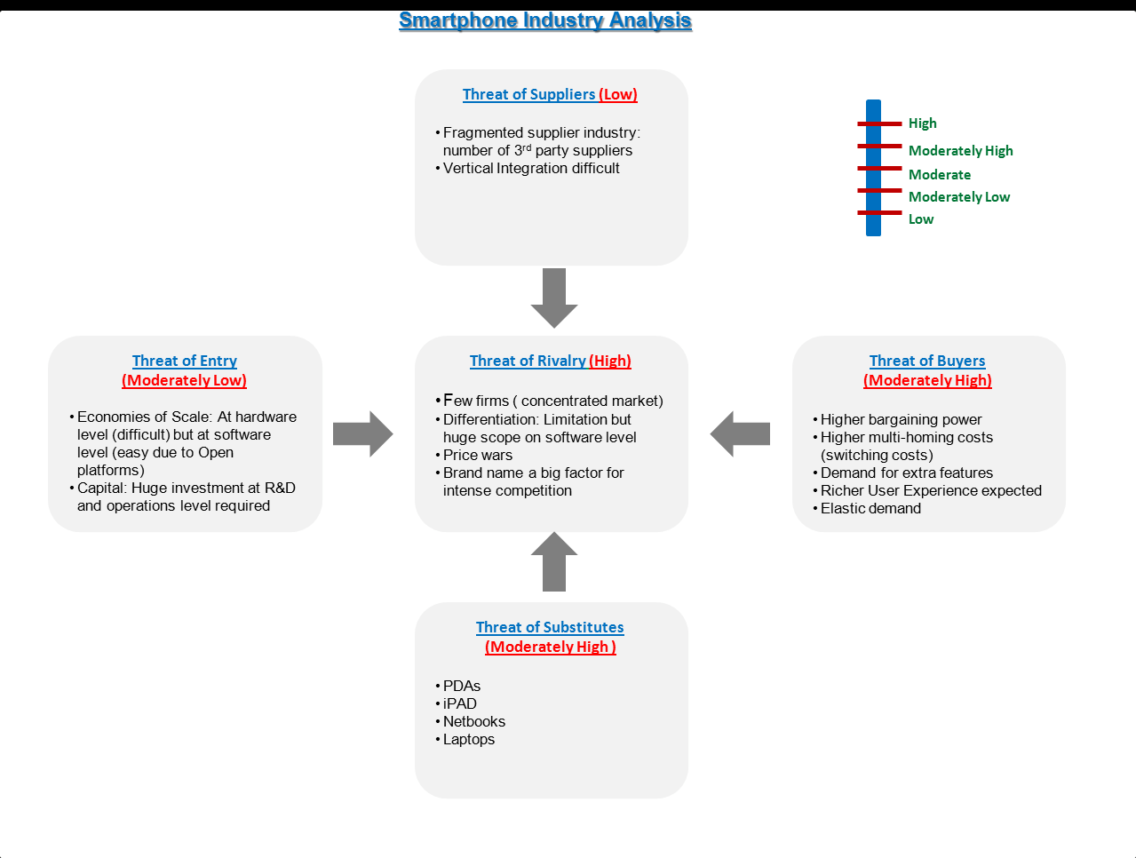

Example of Macro-Environmental analysis (PEST):
- Political: Ireland’s stockmarket and economy are doing so badly because investors know that lots of laws are going to change because of the bank bailout. This creates uncertainty, so investors want a greater return on investment (right now this is about 9% per annum) making it expensive to obtain money.
- Economic: Right now I am trying to sell expensive mobile phones on eBay. But no one in Ireland or Britain wants to buy them because they feel too poor to be buying luxury goods (i.e. goods which are expensive and not absolutely necessary). I therefore put the phones on the German and US eBay instead.
- Technological: See 3D printer handout.
- Social: During the second Iraq War, small businesses in the United States had a terrible time exporting their products because people hated the United States at that time, and unconsciously shunned their products if they knew they were American. This caused the US dollar to rise making it even harder to export goods and contributing to the US$14,000,000,000,000 debt the United States government now has.

